COAL LAB TASKS
Task 01: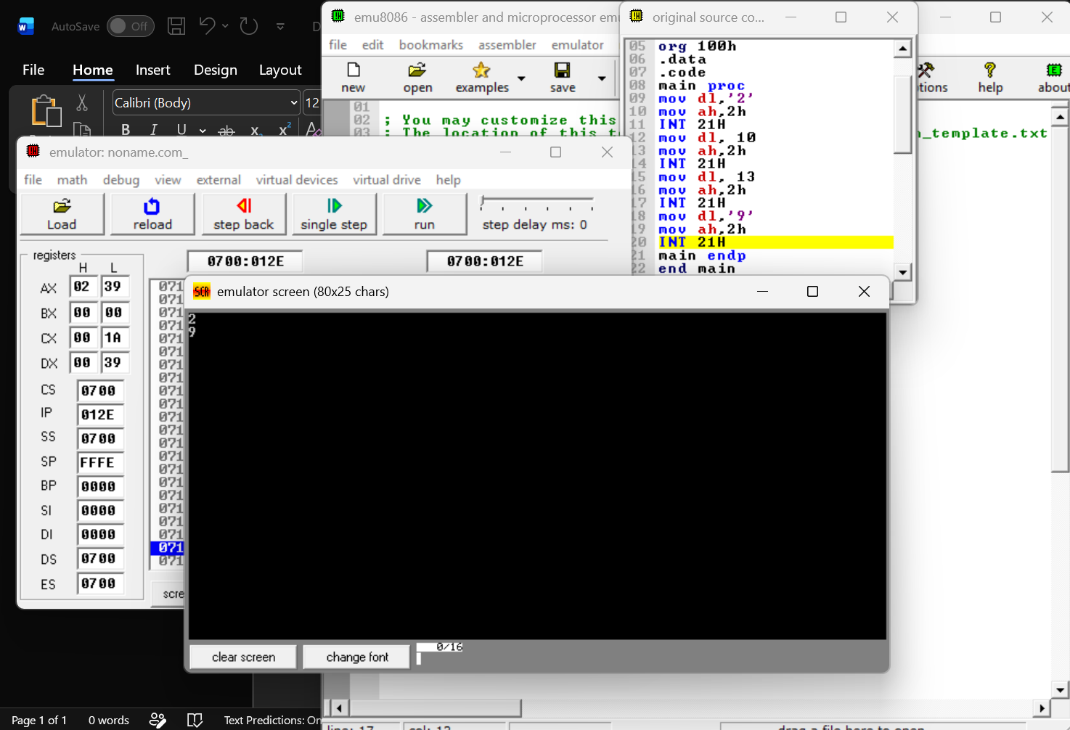 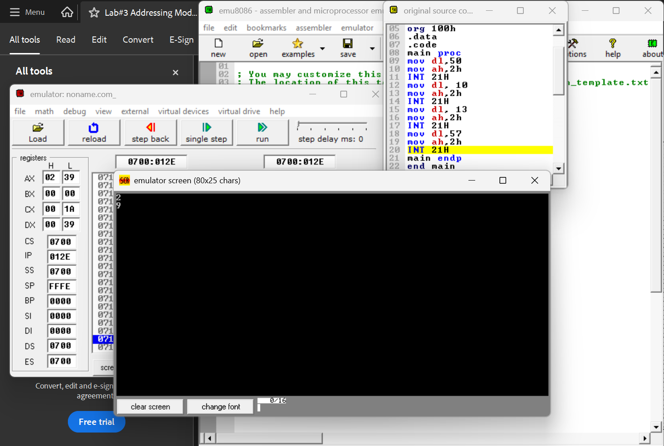

Task 02:
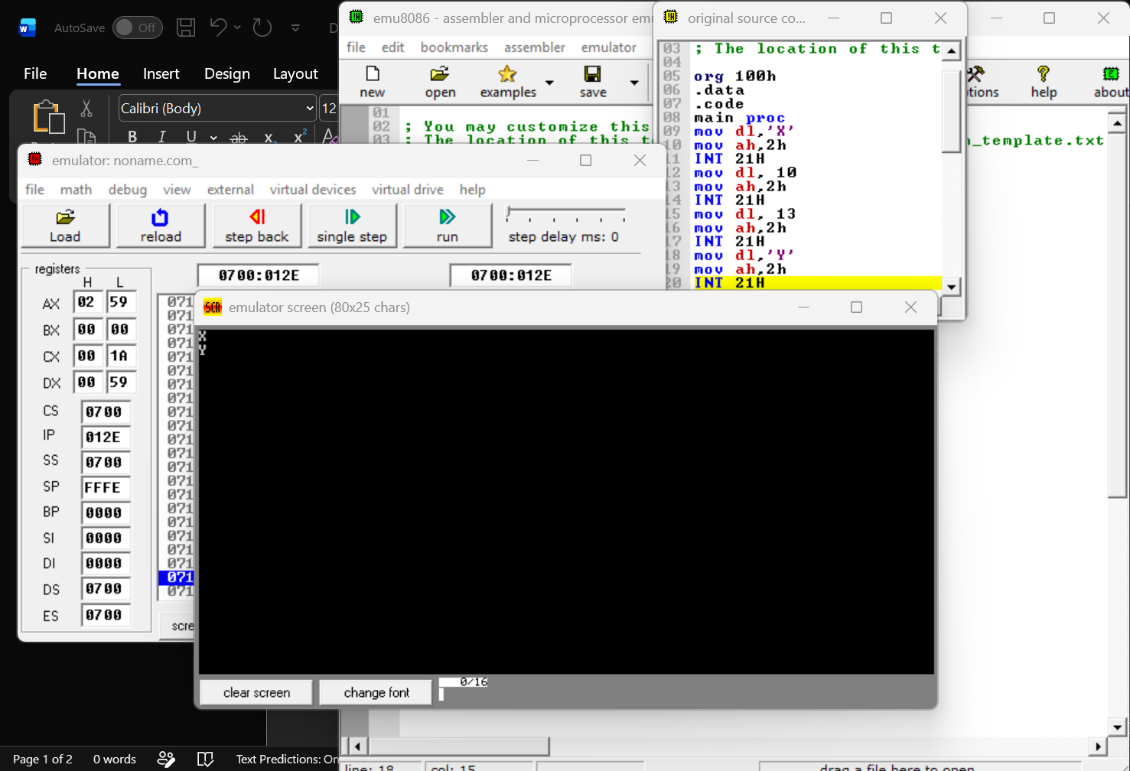
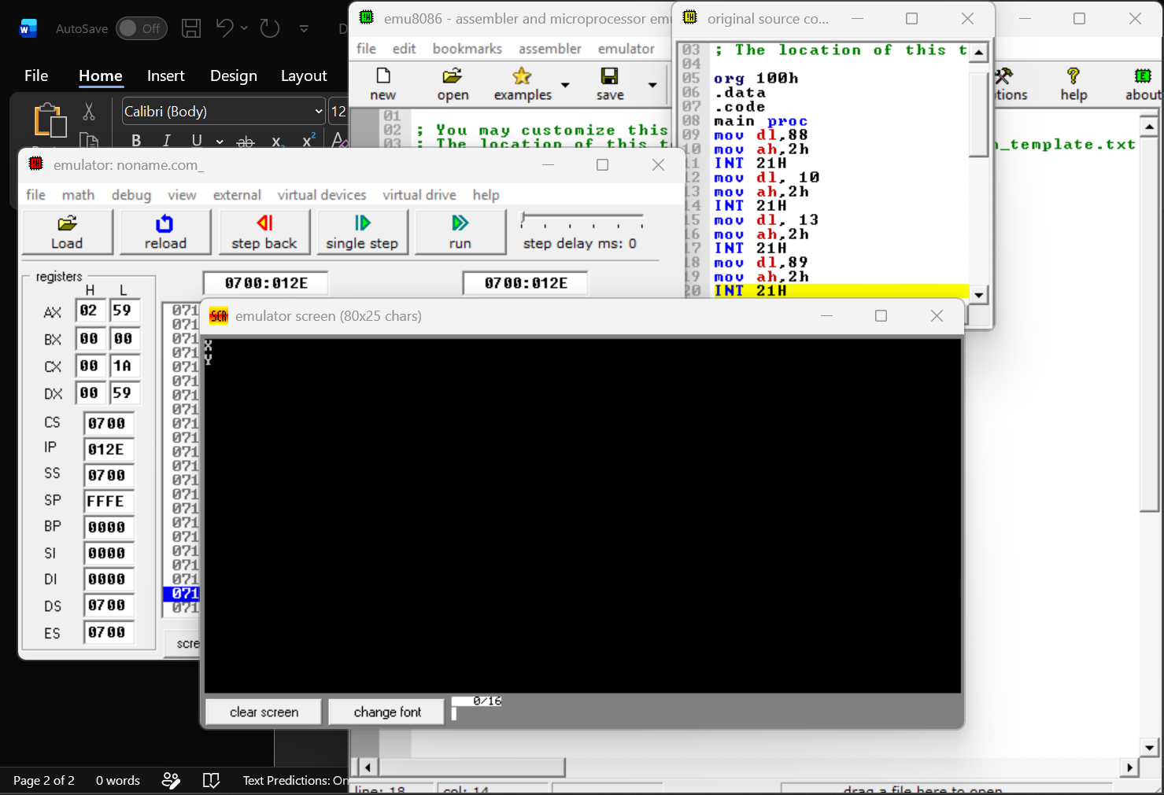
Task 03:
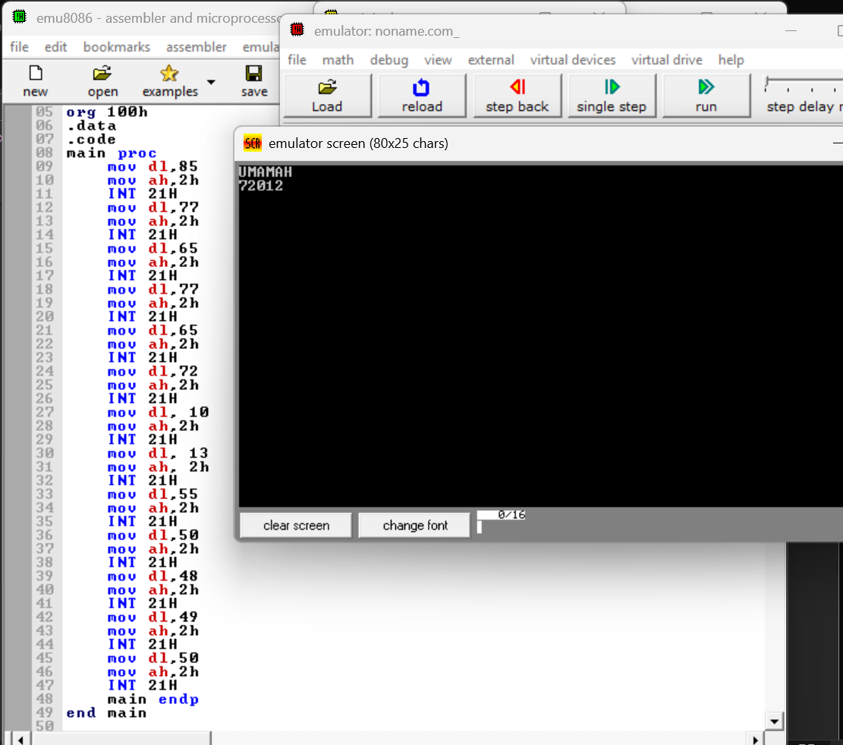

Task 04:
MOV AL, 5 Immediate Addressing
MOV AL, BL Register Addressing
MOV AL, [NUM] Memory Addressing
MOV AL, [SI] Memory Addressing

Task 05:
Addressing mode means how we access different registers and the data stored in them. There are three different ways to access data in registers.
- Immediate Addressing: When one operand is saved in the register, and the other is constant.
- Example: MOV AL, 9
- Memory Addressing: When one operand is saved in the register, and the other is saved in RAM.
Example: MOV AL, [SUM]
- Register Addressing: When both the operands are saved in the register.
Example: MOV AL, DL

